PROJECT REPORT ON
From Traditional BI to Big Data: A Case Study on Netflix’s Scalable Analytics Architecture

Subject Name: Big Data Analytics Subject Code: BDA601
Submitted By: Submitted To:

Kevin Biju Ms. Surbhi

1AY23CD031

Table of Contents:
Topic | Page No:
1.About the Project | 1
2.About the Tools and Technologies Used | 1-2
- Detailed Description of My Contribution  - What is Done and How it is Done  - Code Explanation | 3
4.Implementation Code | 3
5.Results | 3-5
6.Conclusion | 5
TASK 1: Big Data in Daily Life – Visual Storytelling | 5-6
TASK 2: BI vs Big Data – Role Play | 7-9
TASK 3: Architecture Design Challenge | 10-11
TASK 4: Analytics & Tool Match | 12
Bonus Challenge | 13
Figures:  Figure1: Big Data in Daily Life – Visual Storytelling  Figure 2: Hadoop / Big Data Architecture  Figure3: Traditional Data Warehouse Architecture | 6  10  11

Project GitHub Repository

- ABOUT THE PROJECT:

1.1 Big Data Analytics in Netflix – From BI to Intelligent Personalization

Introduction

This project focuses on understanding how Big Data technologies are used in real-world applications like Netflix to analyse massive user data and provide personalized recommendations. Traditional Business Intelligence (BI) systems are limited to structured and batch-processed data. However, modern digital platforms generate high-volume, high-velocity, and high-variety data, which requires scalable Big Data architectures.

Objective
- To study the evolution from Traditional BI to Big Data
- To design both Traditional and Hadoop-based architectures
- To analyse how Netflix uses Big Data for personalization
- To map analytics types with real business questions
Problem Statement
Traditional BI tools cannot efficiently handle unstructured data, real-time streaming, and large-scale distributed systems. Modern platforms like Netflix require scalable, distributed Big Data solutions to analyse user behaviour and improve customer experience.

Scope
- Data classification (Structured, Semi-structured, Unstructured)
- 5 Vs of Big Data
- Architecture comparison
- Analytics mapping
- Real-world recommendation system example

- ABOUT TOOLS & TECHNOLOGIES (DETAILED)

  - Hadoop
- Distributed storage (HDFS)
- Fault-tolerant architecture
- Horizontal scalability

2.2 Apache Spark
- In-memory distributed processing
- Faster than MapReduce
- Used for real-time analytics 1

2.3 NoSQL Databases
- MongoDB / Cassandra
- Stores JSON and unstructured data
- Flexible schema

2.4 Kafka (Streaming)
- Real-time data ingestion
- Handles streaming user events

2.5 Machine Learning Models
- User behaviour prediction
- Recommendation engine
- Collaborative filtering

2.6 BI Tools
- Used for descriptive analytics
- Dashboard and visualization

2.7 Big Query
- Data warehousing
- Analytical queries
You can explain each tool:
- What it is
- Why it is used
- How it supports Netflix

2

- DETAILED DESCRIPTION OF CONTRIBUTION

My Contribution

In this project, I selected Netflix as the real-world Big Data application. I designed two architectures: Traditional Data Warehouse Architecture and Hadoop-based Big Data Architecture. I identified and categorized data into structured, semi-structured, and unstructured formats. I explained the 5V characteristics of Big Data and analyzed why traditional BI systems fail in handling modern data requirements.
I also mapped business questions to analytics types such as Descriptive, Diagnostic, Predictive, and Prescriptive analytics. Additionally, I explained how Netflix’s recommendation engine works using a simplified analogy suitable for better understanding.

IMPLEMENTATION OF CODE

This project is conceptual and architectural in nature. The implementation includes system design, architecture modeling, and analytics mapping rather than executable software development.

- Results

5.1 Overview of Outcomes
The implementation and analysis of the Netflix Big Data architecture demonstrate a clear difference between Traditional Business Intelligence systems and Hadoop-based Big Data systems. The designed architecture successfully shows how large-scale structured and unstructured data can be processed efficiently using distributed technologies.
The results confirm that Big Data systems provide improved scalability, real-time analytics capability, and better personalization compared to traditional centralized data warehouses.

5.2 Comparison Results: Traditional BI vs Big Data
After designing both architectures, the following results were observed:
i. Data Handling Capability
- Traditional BI systems can handle only structured data stored in relational databases.
- Big Data systems can handle structured, semi-structured, and unstructured data such as videos, clickstreams, and user reviews.
Result: Big Data architecture supports diverse data formats required by modern streaming platforms like Netflix. 3

ii. Scalability
- Traditional data warehouses rely on vertical scaling (upgrading a single server), which is expensive.
- Hadoop-based architecture uses horizontal scaling, where multiple nodes are added to the cluster.
Result: Big Data architecture provides cost-effective and highly scalable solutions suitable for millions of users worldwide.

iii. Processing Speed
- Traditional BI mainly supports batch processing (daily or weekly reports).
- Big Data frameworks like Apache Spark enable near real-time processing.
Result: Real-time recommendations and dynamic homepage personalization become possible using Big Data technologies.

iv. Personalization and Intelligence
The predictive and prescriptive analytics layers allow Netflix to:
- Predict user viewing preferences
- Detect potential user churn
- Recommend similar content
- Customize user interfaces dynamically
Result: Big Data enables intelligent decision-making instead of simple historical reporting.

5.3 Business Impact
Based on the analysis, the Big Data architecture contributes to:
- Increased user engagement
- Improved customer retention
- Reduced churn rate
- Higher streaming time per user
- Improved revenue through personalized content delivery
The recommendation engine powered by machine learning significantly improves user satisfaction by showing relevant content.

5.4 Validation Through Analytics Mapping
The Analytics & Tool Match table demonstrates how different types of analytics contribute to business decision-making:
- Descriptive analytics helped understand past viewership trends.
- Diagnostic analytics identified reasons behind engagement spikes.
- Predictive analytics forecasted future content preferences. 4
- Prescriptive analytics suggested actions such as recommending specific shows.
Result: The combination of all four analytics types ensures data-driven strategic decisions.

5.5 Conclusion of Results
The study confirms that traditional BI systems are insufficient for handling modern digital platform requirements. Hadoop-based Big Data architecture provides:
- Distributed storage
- Parallel processing
- Real-time analytics
- AI-driven recommendations
Thus, Big Data transforms raw user activity into actionable insights, enabling Netflix to deliver a personalized and scalable streaming experience.

TASK 1: Big Data in Daily Life – Visual Storytelling

5
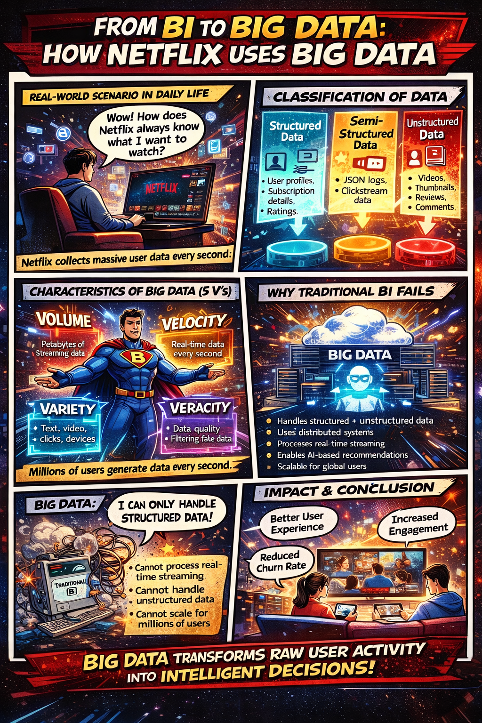

Figure 1(visual storytelling)

6

TASK 2: BI vs Big Data – Role Play
Scenario:
A Data Consultant explains the importance of Big Data to a Business Manager who believes Excel and SQL are sufficient.
Characters:
- Rahul – Business Manager
- Arjun – Data Consultant

Rahul: I don’t understand why we need Big Data technologies. Excel and SQL reports are working perfectly fine for our company.
Arjun: They work well for structured and limited datasets. However, modern businesses generate massive volumes of real-time and unstructured data that traditional BI tools cannot efficiently handle.
Rahul: What exactly are the limitations of traditional BI systems?
Arjun: Traditional BI systems primarily handle structured data stored in relational databases. They struggle with processing unstructured data like social media posts, reviews, images, and videos. They also lack scalability and cannot process real-time streaming data efficiently.
Rahul: But we generate monthly sales reports without any problem.
Arjun: Monthly reporting is historical analysis. Today’s competitive environment demands real-time analytics, predictive insights, and faster decision-making — something traditional BI was not designed for.
Rahul: When did this shift toward Big Data begin?
Arjun: With the rise of digital platforms, e-commerce, social media, and IoT devices. Data began growing in Volume, Velocity, and Variety — commonly known as the core characteristics of Big Data.
7
Rahul: So Big Data evolved because traditional systems couldn’t handle this scale?
Arjun: Exactly. Organizations needed distributed systems capable of storing and processing terabytes and petabytes of data across multiple machines.
Rahul: How does Hadoop help in this situation?
Arjun: Hadoop uses distributed storage (HDFS) and parallel processing. Instead of relying on a single high-end server, it distributes data across multiple systems, making it highly scalable and cost-effective.
Rahul: And why is NoSQL required when we already have relational databases?
Arjun: Relational databases require predefined schemas and structured tables. NoSQL databases can store semi-structured and unstructured data such as JSON documents, key-value pairs, and large datasets. They provide flexibility and horizontal scalability.
Rahul: Does Big Data provide measurable business benefits?
Arjun: Absolutely. Big Data enables personalized recommendations, fraud detection, customer behaviour analysis, demand forecasting, and predictive analytics. These lead to improved customer experience and better strategic decisions.
Rahul: Can you give a practical example?
Arjun: Companies like streaming platforms use Big Data to recommend content based on user behaviour. E-commerce platforms analyse browsing patterns to suggest products. Banks detect fraudulent transactions in real time.
Rahul: That seems like a competitive advantage.
Arjun: It is. Businesses that adopt Big Data technologies can analyse both historical and real-time data, improve operational efficiency, reduce customer churn, and increase revenue.

8
Rahul: So, Excel and SQL are not obsolete, but insufficient for modern large-scale data challenges?
Arjun: Exactly. Traditional BI tools are useful for structured reporting, but Big Data technologies are essential for handling high-volume, high-velocity, and high-variety data in today’s digital economy.
Rahul: I see your point. Big Data is not just about storage it’s about gaining intelligent insights for better decision-making.
Arjun: Precisely. Big Data transforms raw information into actionable intelligence, giving businesses a strong strategic advantage.

9

TASK 3: Architecture Design Challenge
1.Hadoop / Big Data Architecture

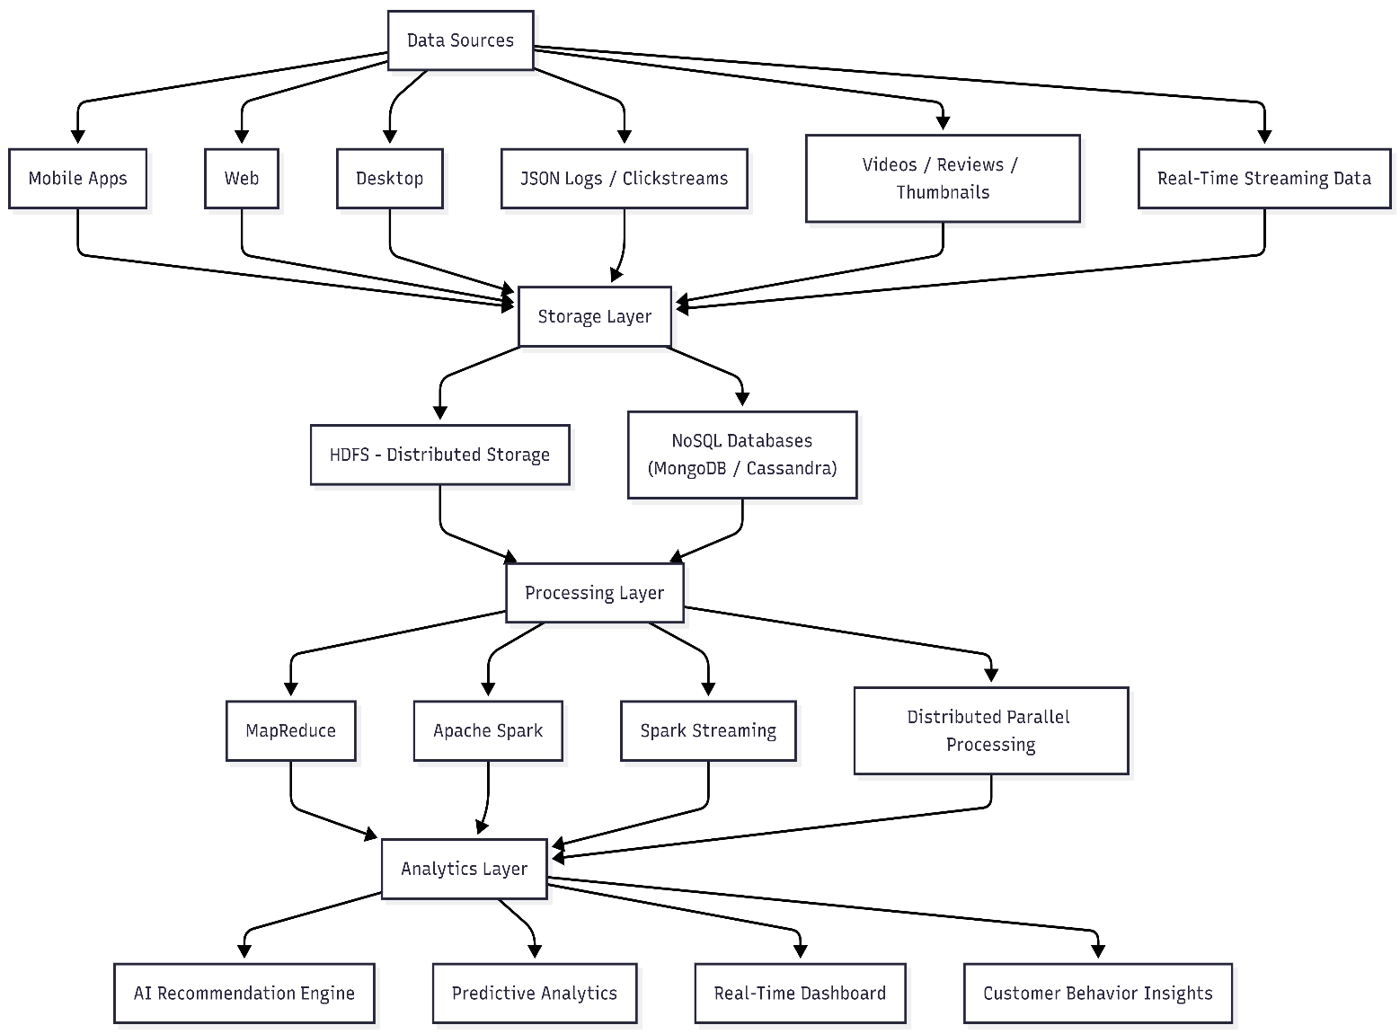

Figure 2(Hadoop / Big Data Architecture)

10

2.Traditional Data Warehouse Architecture
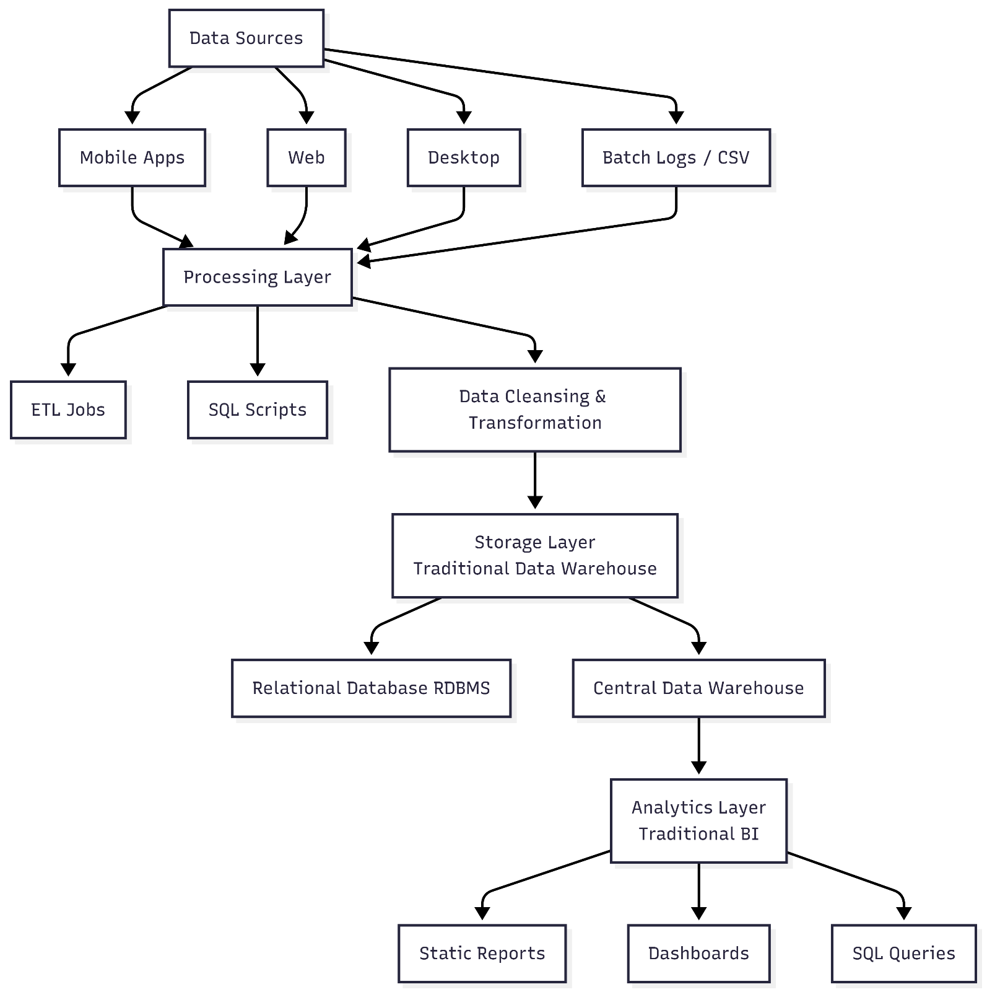
figure 3(Traditional Data Warehouse Architecture)
11

TASK 4: Analytics & Tool Match

Business Question | Analytics Type | Big Data Tool | Netflix Example
What happened? | Descriptive Analytics | BI Tools + SQL + Hadoop | “Viewership peaked during weekends.” “Most watched genre this month: Thriller.”
Why did it happen? | Diagnostic Analytics | Hadoop + Spark + SQL | “Thriller content increased because a new crime series was released.” “User engagement increased due to push notifications.”
What will happen next? (Future trends) | Predictive Analytics | ML Models + Spark MLlib + BigQuery | “User likely to watch Action movies next.” “This series will trend next month.” “Churn probability is high for inactive users.”
What action should be taken? (Recommendations) | Prescriptive Analytics | Kafka + Spark + NoSQL + Personalization Engine | “Recommended for You section updated.” “Because you watched Money Heist, try these similar shows.” “Send re-engagement email to inactive users.”

12

Bonus Challenge
“Explain Big Data to a 10-year-old”
Imagine you have a huge magic notebook that writes down everything people do what cartoons they watch, what games they play, what songs they like, and even what time they use their tablet. Now imagine millions of children around the world using their tablets at the same time. That notebook would become so big that a normal computer could not handle it. Big Data is like a super-smart system that can store all that huge information, organize it quickly, and learn patterns from it. For example, if you watch many superhero movies, Big Data helps a streaming app understand that you probably like superheroes and will suggest more similar movies. It works very fast, handles different kinds of information (videos, clicks, searches), and helps companies make smarter decisions. In simple words, Big Data is a powerful way of collecting and understanding massive amounts of information to make things more personalized and useful for everyone.

13

